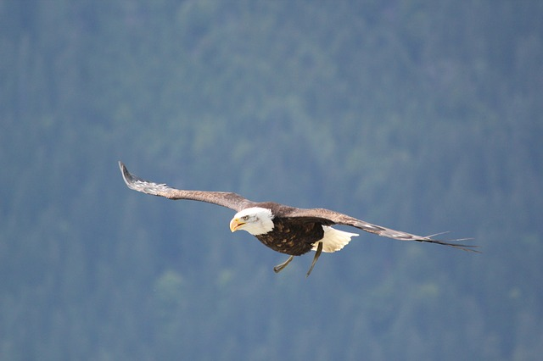
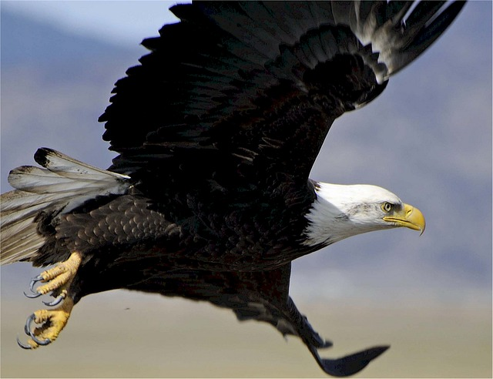
Pictures are free from pixaby.com
Printable by futureflyingsaucers.com

